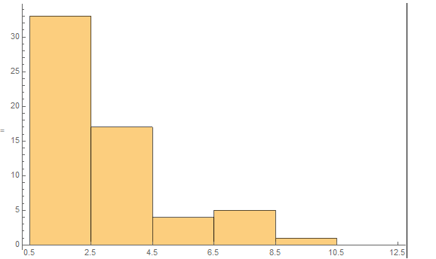

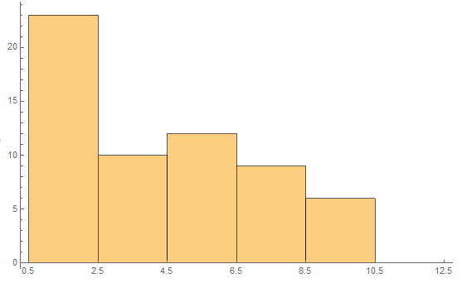The first histogram is the frequency of the first digit of the sheer modulus of different elements in N/m^2.

The second histogram is in the unit of oz/ft^2. From the two histograms we can see most data start with digital 1, while the others depends on the units.